



present

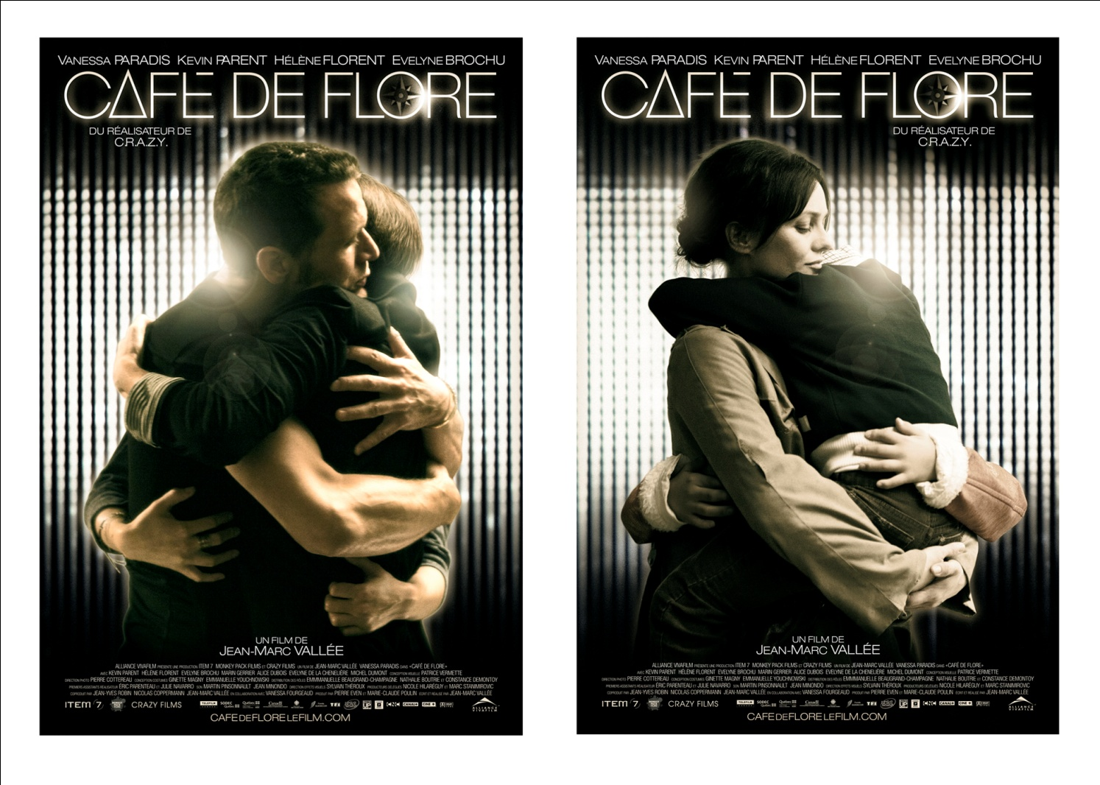
A co-production Canada-France


THEATRICAL RELEASE IN CANADA: SEPTEMBER 23, 2011
www.cafedeflorelefilm.com
Canadian Distributor

• • •
Shooting : MONTREAL : August 16th to September 24th, 2010
PARIS : October 23th to November18th, 2010
genre: Love Drama
format: 35 MM
original version: French with English subtitles
origin: Canada in co-production with France
Theatrical release in Canada: September 23rd, 2011

PRODUCTION:
Producers: Pierre Even and Marie-Claude Poulin – Item 7
Co-producers: Jean-Yves Robin, Nicolas Copperman, in collaboration with Vanessa Fourgeaud – Monkey Pack Films
Co-Producer: Jean-Marc Vallée – Crazy Films

Produced with the financial contribution of:
Canada :
Téléfilm Canada / SODEC / Société Radio-Canada / Crédit d’impôt cinéma et télévision - gestion SODEC / Crédit d’impôt – Canada / Fonds Quebecor

France :
Tf1 DA / UGC / Canal Plus / Ciné Cinéma / Banque postale Image 4 /Cnc Fonds de soutien
Sofica Coficup - Back up films

CANADA DISTRIBUTOR :
Alliance Vivafilm
PHOTOS www.alliancefilmsmedia.com
Cliquez sur l’onglet « Apply for an account »
Remplissez le formulaire et un mot de passe vous sera envoyé par courriel
EPK (Bande-annonce & extraits)
http://alliance-epk.mijonet.com
Enregistrez-vous afin de pouvoir télécharger le matériel en différents formats
RELATIONS DE PRESSE : Annie Tremblay Alliance Vivafilm 514 878-2282

FRANCE DISTRIBUTOR :
TFI DA UGC

INTERNATIONAL REPRESENTATION:
FILMS DISTRIBUTION

SYNOPSIS

Healing a broken heart isn't easy. Sometimes it takes a lifetime...or two.

Cafe de Flore is a love story about people separated by time and place but connected in profound and mysterious ways. Atmospheric, fantastical, tragic and hopeful, the film chronicles the parallel fates of Jacqueline, a young mother with a disabled son in 1960s Paris, and Antoine, a recently-divorced, successful DJ in present day Montreal. What binds the two stories together is love - euphoric, obsessive, tragic, youthful, timeless love.

Jean-Marc Vallée
Director, writer
Biography

Montreal filmmaker Jean-Marc Vallée made his ground-breaking feature debut with “Liste Noire” (Black List), in 1995. The strikingly stylish erotic thriller was a first for its genre in Quebec cinema, and was honored with nine Genie Award nominations. Ten years later, he returned to French-language features with the internationally acclaimed hit, “C.R.A.Z.Y. ” Blending a beguiling coming-of-age tale with a magical ode to outsiders of all ages, the powerful yet poignant C.R.A.Z.Y.’s intensely personal story embraces universal themes. The picture became a phenomenon; distributed in over fifty countries and winning some twenty international festival awards – including the prestigious “Best Canadian Film” prize at the 2005 Toronto International Film Festival, 11 Genie Awards, 15 Jutra Awards, and the Golden Reel Award as Canada’s top-performer at the domestic box office.

Jean-Marc has also flirted with Hollywood (Strangers –1996, Los Locos-1997), as well as completing the first two instalments of his short film trilogy devoted to father-son relationships; a theme very close to the filmmaker’s heart. “Les Fleurs magiques” (Magical Flowers, 1995) and “Les Mots magiques” (Magical Words, 1998) are individual pieces unified by a dream-like quality, and an eye for their subjects that is both tender and tortured. Both shorts were awarded numerous festival prizes at home, and abroad.

His lates film “The Young Victoria”, produced by Graham King and Martin Scorsese, won an Oscar for Best Costumes in 2010 and received nominations for Best Art Direction and Best Makeup. His next film is “Café de Flore”, starring Vanessa Paradis and Kevin Parent, which he wrote and directed.

MOT DU RÉALISATEUR

Dans sa réalisation, Café de Flore est la continuation du défi que représentait C.R.A.Z.Y., à la différence près que ce film pousse plus loin son exploration du fantastique, et qu’il visite de nouveaux thèmes.

Mais mon approche reste la même : raconter une histoire avec le désir sincère de donner le meilleur spectacle possible.

Et il y a tout un spectacle à donner avec cette histoire d’amour qui s’échelonne sur une cinquantaine d’années, à deux époques différentes, et où la musique joue un rôle encore plus capital que celui qu’elle tenait dans C.R.A.Z.Y.

Ici, la musique devient outil. Un outil d’abord au service de tous les personnages du film, puis à celui de l’émotion et de la romance.

C.R.A.Z.Y. m’a littéralement donné des ailes pour oser voler haut, pour oser explorer des territoires inconnus.

Café de Flore est le fruit de cette envolée. À partir du concept d’âme sœur qui nourrit le récit, je me suis imaginé une histoire que j’ai voulue romantique, dangereuse, fantastique et belle. Pour me faire plaisir à nouveau, pour me permettre de m’éclater, de « spinner », de faire le genre de film que j’aime. Un film qui, je l’espère, saura toucher, surprendre, donner la chair de poule, et faire partager le sentiment de bonheur que me procure la musique au cinéma, et au quotidien.

Jean-Marc Vallée

CREDITS
Director: Jean-Marc Vallée Canadian
Writer: Jean Marc Vallée Canadian
Producers (Canada): Pierre Even Canadian
Marie-Claude Poulin Canadian
Co-producer: Jean-Marc Vallée Canadian

Co-producers (France): Nicolas Coppermann French
Jean-Yves Robin French
In collaboration with Vanessa Fourgeaud French

Line Producers: Nicole Hilaréguy Canadian
Marc Stanimirovic French

Cinematographer: Pierre Cottereau French

Art Direction: Patrice Vermette Canadian

Editing: Jean-Marc Vallée Canadian

Sound: Jean Minondo French
Martin Pinsonnault Canadian

Special Effects: Marc Coté Canadian

Costumes: Ginette Magny Canadian
Emmanuelle Youchnowski French

Makeup: Christiane Fattori Canadian
Frédéric Marin French

Hair Stylist: Ghyslaine Sant Canadian
Frédéric Birault French

Photographer: Sébastien Raymond Canadian

Casting: Emanuelle Beaugrand-Champagne Canadian
Nathalie Boutrie Canadian
Constance Demontoy French

4

Cast
Jacqueline Vanessa Paradis
Antoine Godin Kevin Parent
Carole Hélène Florent
Rose Evelyne Brochu
Laurent Marin Gerrier
Véronique Alice Dubois
Amélie Evelyne de la Chenelière
Julien Godin Michel Dumont
Louise Godin Linda Smith
Juliette Joanny Corbeil-Picher
Angéline Rosalie Fortier
Psychologue Michel Laperrière
Mère de Véronique Caroline Bal
Père de Véronique Nicolas Marié
Paul Pascal Elso
Louis Jérôme Kircher
Mme Labelle Claire Vernet
La Maîtresse d’école Manon Balthazard
Antoine (14 ans) Émile Vallée
Carole (14 ans) Chanel Fontaine
La médium Emanuelle Beaugrand-Champagne

CAFÉ DE FLORE
(Matthew Herbert)
Bucks Music Group
Interprété par Matthew Herbert

CORONA RADIATA
(Michael Trent Reznor)
Form and Texture Inc.
Interprété par Nine Inch Nails
Avec l’autorisation de The Null Corporation

JUST LIKE HEAVEN
(William Bransby, Simon Gallup, Robert Smith,
Paul Thompson, Laurence Tolhurst, Roger O’Donnell)

MEANINGFUL MOMENT THROUGH A MEANING (LESS) PROCESS
(Adam Witzie)
Kranky Limited
Interprété par Stars of the Lid

PICTURES OF YOU
(William Bransby, Simon Gallup, Robert Smith,
Paul Thompson, Laurence Tolhurst, Roger O’Donnell)
Universal Music Publishing
Interprété par The Cure

SPEAK TO ME
(Nick Mason, Roger Waters)
The Richmond Organization pour Hampshire House Publishing - Pink Floyd Music Publishing
Interprété par Pink Floyd

BREATHE
(David Gilmour, Roger Waters, Richard Wright)
The Richmond Organization pour Hampshire House Publishing - Pink Floyd Music Publishing – Warner/Chappell Music, Inc.
Interprété par Pink Floyd

TIME
(David Gilmour, Roger Waters, Richard Wright, Nick Mason)
The Richmond Organization pour Hampshire House Publishing - Pink Floyd Music Publishing– Warner/Chappell Music, Inc.
Interprété par Pink Floyd

SVEFN-G-ENGLAR
(Jon Thor Birgisson, August Aevar Gunarsson, Georg Holm, Kjartan Sveinsson)
Universal Music Publishing
Interprété par Sigur Ros
Avec l’autorisation de PIAS

FLJOTAVIK
(Jon Thor Birgisson, August Aevar Gunarsson, Georg Holm, Kjartan Sveinsson)
Universal Music Publishing
Interprété par Sigur Ros

WALKING ON THE WATER
(Tom Fogerty, John Fogerty)
Jondora Music, a division of Fantasy Inc.
Interprété par Creedence Clearwater Revival (CCR)

NAVVAATARA
(Élisapie Isaac)
Avalanche Sound Publishing
Interprété par Élisapie Isaac

LE VENT NOUS PORTERA
(Bertrand Cantat, Denis Barthe)
Universal Music Publishing
Interprété par Sophie Hunger

DUTCH TILT
(Dean Newton)
Premier Musik International Corp.
Interprété par Dean Newton

COMME UN SOLEIL
(Pierre Delanoë, Michel Fuguain, George Blaness)
Big Baazar Music Publishing Co. pour Éditions Musicales Le Minautore

BIG FREEZE
(Serge Pelletier, Mathieu Pontbriand, Christian Baang, Joseph Perrault, Sara Belle Humble)
Éditorial Avenue
Interprété par Pawa Up First

HEY, THAT’S NO WAY TO SAY GOODBYE
(Leonard Cohen)
Sony/ATV SMusic Publishing pour Leonard Cohen Stranger Music Inc.
Interprété par Leonard Cohen



PIERRE EVEN, PRODUCER
MARIE-CLAUDE POULIN, PRODUCER

ITEM 7 was founded in 2009 by industry veterans, Pierre Even and Marie-Claude Poulin. Their combined experience, collaborations over the years and privileged relationships in the Canadian and international film industry will no doubt serve to quickly position ITEM 7 as one of the leading productions companies in Canada.
The company will concentrate on producing Canadian and international feature films that will reach wide audiences in both French and English with a focus on working with the most creative and innovative talents in the country.
Item’s 7 ultimate goal is to insure that each picture is of the highest standard by giving attention to details at all stages of production and carried through domestic and international distribution.
First theatrical release for Item 7 is LIFE BEGINS (Une vie qui commence) first feature film of the famous theater director, Michel Monty, in coproduction with Cirrus Communications. The film won a Bayard D’Or for Best First Film at the Namur Film Festival. Presently in post production CAFÉ DE FLORE a film by Jean-Marc Vallée (C.R.A.Z.Y. The Young Victoria) a coproduction with the French producer Monkey Pack Films starring Vanessa Paradis. CAFÉ DE FLORE was shot in Montreal and Paris. The film will be released in the fall in Canada (Alliance) and France (TF1/UGC and is being sold internationally by Films Distribution.
They are now in post-production on their third feature, KOMONA, shot in Kinshasa (DRC) in summer 2011. The film was written and will be directed by Kim Nguyen (La Cité, Truffes).
The partners:
Pierre Even first started in the industry a head of business and legal affairs for Malofilm Distribution and Production taking an active part in both aspects of the business.
After a stint as producer of Variety TV at Just For Laughs where is honed his production skills, Mr. Even refocused his career on feature films by accepting a position at Telefilm Canada where he became director of the feature film Unit for 4 years enabling him to develop an expertise in the area of governmental support of culture in Canada and gain knowledge about Canada’s vibrant creative community.
Mr. Even left Telefilm in 2002 to join Cirrus Communications to head their newly launched feature film division. He set up and managed the division for 7 years producing films that enjoyed both domestic and international success. C.R.A.Z.Y. directed by Jean-Marc Vallée: released in 2005, the film won the golden reel in 2005 garnering over 6.2 million at the box office. It won 51 international prizes and was sold in 85 countries; Nitro directed by Alain DesRochers: released in the summer of 2007, the film grossed 1.2 million in its opening weekend, beating all Hollywood blockbusters; Le Banquet directed by Sebastien Rose: the film was released in August 2009 and received critical acclaim; 5150 Elm’s Way directed by Eric Tessier: based on the bestselling book by Patrick Senecal, the film starring Marc André Grondin has grossed over 1 million dollars in Québec. Mr. Even also produced two co-productions: With Ontario, Hank and Mike, directed by Matthew Klinck and Modern Love, a French co-production directed by Stephane Kazandjian starring popular comedian Stéphane Rousseau.

Marie Claude Poulin started her career in Toronto as director of domestic and International sales for Norstar Releasing. She then moved to Montreal to head Malofilm’s newly created international department where she also acted as director of acquisitions actively taking part in the development of local projects.
Her career continued in the international sales side of the business at CFP where she set up the foreign sales department which became Lionsgate International. She was responsible for the international success of some notable independent pictures (American Psycho, Vincent Gallo’s Buffalo 66 ).

When operations moved to L.A. Ms. Poulin chose to remain in Montreal and explore the financing side of the business at financing entity FIDEC. This led to Melleny Productions where she actively seconded producer R. Goudreau for Les Boys 3 and executive produced Aftermath. The last 9 years have been spent as head of distribution for TVA Films and Equinoxe Films where she has helped develop several projects and bring to the screens several memorable films including The Pianist, C.R.A.Z.Y., and Hurt Locker.

Item 7 also has several projects in development including, The Colony, My Camino (Canada/Spain co production), Meetings with a Young Poet, Birthmarked, The Hum (Canada /UK), as well as several French language Québec based projects.

CRAZY FILMS

Profil corporatif

Films Crazy Inc. (Crazy Films) a été fondée par Jean-Marc Vallée le 4 octobre 2002 dans le but de produire le film « C.R.A.Z.Y. ».

Son scénariste, réalisateur et co-producteur, Jean-Marc Vallée, oeuvre dans le domaine du cinéma depuis 1985.

Crazy Films et Cirrus Communications s’associent en 2003 pour créer la compagnie Productions Zac avec laquelle ils produisent « C.R.A.Z.Y. ».

Crazy Films et Item 7 s’associent en 2010 pour créer la compagnie Productions Café de Flore avec laquelle ils produisent actuellement le film « Café de Flore ».

Le but actuel de Crazy Films est de développer les projets d’écriture de long-métrage de son fondateur : des projets ambitieux et personnels à caractère fantaisiste dans l’esprit du film « C.R.A.Z.Y. ».

MONKEY PACK FILMS est la filiale cinéma du groupe ROBIN&CO.

Elle développe aussi bien des projets originaux que les films des talents maison qui évoluent sur scène et sur le petit écran à travers ses filiales. De ce fait, MONKEY PACK FILMS est fière d’avoir produit les long-métrages Espace Détente (1,8M de spectateurs) et Le Séminaire, adaptés du programme court Caméra Café, produit par CALT. MONKEY PACK FILMS est également producteur de Mammuth de Benoit Delépine et Gustave Kervern, avec Gérard Depardieu, Yolande Moreau et Isabelle Adjani sorti en 2010.

Nos choix visent à séduire et surprendre un large public. Les relations privilégiées que nous entretenons avec nos partenaires nous permettent de défendre et porter les films de nos artistes, pour les produire dans les meilleures conditions.

Aujourd’hui, notre société prépare d’ailleurs l’adaptation cinéma de la série culte Kaamelott, écrite et réalisée par Alexandre Astier.

Nous développons par ailleurs plusieurs projets originaux français et internationaux, notamment :

Gravity3D, documentaire en 3D relief en coproduction avec Bonne Pioche, réalisé par Mark Obenhaus ; Sea Shepherd, The Adventures of Paul Watson, coproduction internationale avec le Canada et l’Australie ; le premier film de Fred Scotlande, Happy Hour, actuellement en casting, et le prochain long-métrage de Jean-Marc Vallée (C.R.A.Z.Y.) intitulé Café de Flore en coproduction avec Item7.

