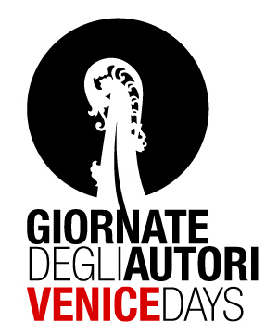

LAURA CAFIERO and GABRIELLA GALLUZZI
present

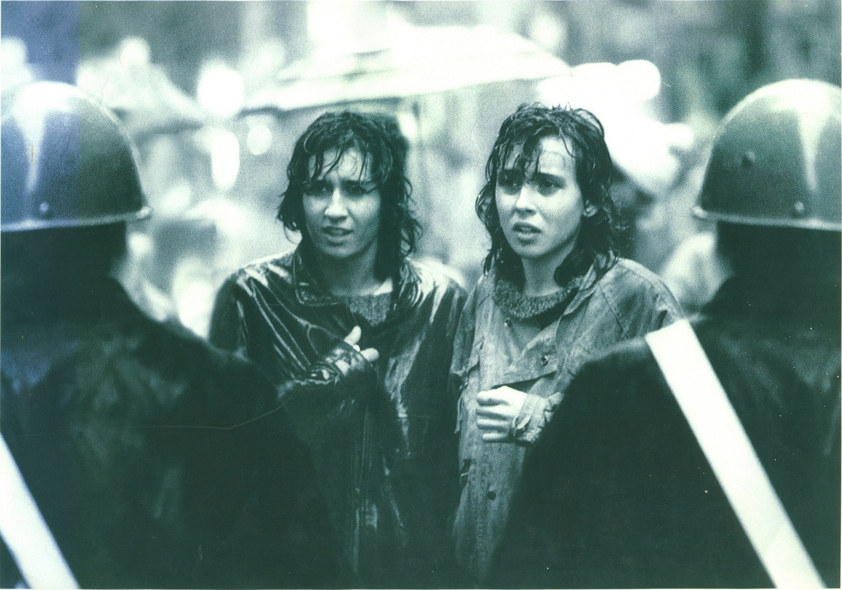

Girls life is trembling

a film by
Paola Sangiovanni

produced by
METAFILM and FAKE FACTORY
Girls life is trembling
Sipnosis

Alessandra, Maria Paola, Marina and Liliana come from different geographical, cultural and social milieu and their lives crossed or just grazed each other in Rome between the end of the sixties and during the seventies.
Their stories, told in first person today, are completed by vivid and present images from library audiovisual stock, in part private and never shown. It is told from a personal point of view. The "coming from oneself", formulated spontaneously during the Feminism season and was the basis of a new way making politics, now becomes historical narrative today.
The story of the idea for a new world arose simultaneously in the whole country in the hearts of nearly an entire generation, a world in which "there was no violence, no misuse of power", a story unfolding along the parallel track of women's history. The awareness of oneself as a woman, self-awareness, loves, violence against women, divorce, contraception and abortion, work, theatre, free radios, sit-ins, moving personal experiences into collective ones for a more human world, of women and men, girls and boys.
"Such an exiting period, revolutionary in the true meaning of the word, where step by step we obtain changes, changes that last and have altered the aspect not only of our lives, but also of the country we lived in and are living in today", Liliana says.
"Well, probably it was not possible to make a revolution in Italy, thousands of mistakes have been made, but due to these mistakes everything has been cancelled, a pitiful veil has spread over everything. Why did we end up there?" Alessandra begins.
Our girls are in theory responding to today's twenty and thirty year olds. We have to remember, give space and time to our memory in order to know who we are today.

Girls life is trembling
The girls

MARIA PAOLA FIORENSOLI
Born in 1947 in Turin, living in Rome since 1968, belonging to a Catholic milieu, she joined the Rome University "La Sapienza" sit-ins and several feminist groups. Editor for radio broadcasts and for the newspaper The Women's Country.

LILIANA INGARGIOLA
Born in Rome in 1947 to a proletarian family from the south of Italy. Activist in the Radical Party and leader of the Women's Liberation Movement during the fight for legalising abortion and against violence to women. In the eighties she left politics and dedicated herself to psychotherapy.

MARINA PIVETTA
Born in Venice in 1948 to a family of artists, living in Rome since 1974. For a few years she was an activist in Avanguardia operaia (Worker's Forefront), reporter for Il quotidiano dei lavoratori (Worker's Daily) and Quotidiano donna (Women's Daily), editor for Radio Città Futura and Radio Donna. For many years she was a reporter for the RAI Radio Tre news.

ALESSANDRA VANZI
Born in Rome in 1955. At the age of sixteen she got married and gave birth to a daughter, at the age of seventeen she decided to part from her husband when there still was no divorce in Italy and the legal age was twenty-one. At nineteen she started performing in the theatre and was co-founder of La Gaia Scienza, famous leading theatre group of the Roman avant-garde in the seventies. She is an actress as well as a director and an author.

Girls life is trembling
Director’s notes

For me, ‘Girls, life is trembling’ is above all a film about memory and its transmission, and about the chance for historic narration. In order to make it I met with many women and heard a lot of stories before choosing the four leading characters – stories about the days when I was little more than a child. I listened to archive recordings and watched images. I tried to create an empathetic relationship with all this, which became a method, a sort of emotional circularity, which history finds difficult to communicate. I think it is a demanding emotion, which would like to lead those who watch and listen to active participation, to an enlivened and present memory.

Ragazze la vita trema
Technical information

genre: documentary

runtime: 85 minutes

format: shooting: HDV
audiovisual archives: various formats
screening: 35mm

author and director: Paola Sangiovanni

produced by : Laura Cafiero
for Metafilm and Fake Factory
with the contribution of
Paneikon and Banca Nuova
with the contribution and patronage of
Province of Rome
(Department of Economic, Financial and Budget Policies)
Presidency of the Lazio Regional Council

music: original music: Giorgio Giampà

repertory:
F. De André "Secondo intermezzo" and "Inverno"
Nada "Ma che freddo fa"
P. Piccioni "L'attico"
E. Pierannunzi "Just Beyond the Horizon"
P.F.M. "E' festa" and "Impressioni di settembre"
A. Trovaioli "Profumo di donna"

archive images: Aamod, Teche Rai, Homemovies, Acab Associazione Antonello Branca, Radio Radicale, Radio Città Futura, private archives.

photography: Eleonora Patriarca

editing: Nicola Moruzzi

direct sound: Maximilien Gobiet

sound editing: Daniela Bassani, Marzia Cordò and Stefano Grosso

Girls life is trembling
Director’s bio/filmography
Paola Sangiovanni was born in Rome in 1965, received her degree in Cinema History and Critique and for many years worked in Italian and international TV and cinema productions as assistant director and script supervisor. She has directed many short films. Ragazze la vita trema is her first feature film.

OGNI COSA AL SUO POSTO - 35mm, 11’, produced by Tommaso Calevi for Toma film, 1993. Reviews and festivals, among them Clermont-Ferrand, Arcipelago, Bellaria, Arezzo cinema indipendente ‘93; Capalbio’94; Stuttgarter, Bucarest, Trevignano ’95.
VOCALI - videoarte –betacam, 5’, 1994. Reviews and festivals including: Scrittura e Immagine, Pescara ’94; Elettroshock 30 anni di video in Italia, Rome ’01, Madrid, Paris, Montreal, Berlin ’04, Pesaro ’05, Beijing ‘07
SENZAPATRIA - docufiction, 35mm, 5’, prod. Dune, 1996 part of the collective film Intolerance. Sguardi del cinema sull’intolleranza promoted by Cinema Without Borders, Arci Nero e Non Solo, Anac-Aic.
VOCI – minidv/dvcam/super8/35mm, 18’, prod. Mediaclip, 2001. Reviews and festivals among them Arcipelago ’01; Siena, Valdarno Fedic, Drama ’02.
DIETRO L’ORIZZONTE – special about the film L’orizzonte degli eventi by Daniele Vicari, minidv/dvcam, 40’, prod. Fandango-Medusa-Sky, distrib. Medusa 2005
DIARIO DI UN SUPERAMORE – documentary, betacam/minidv, 15’, prod. Cineteca di Bologna, 2005. Study days promoted by Cineteca, Province, Regional Order of Journalists, Bologna ’05
STAFFETTE – documentary - minidv/betacam, library stock in various formats. 55’, prod. Metafilm, 2006, international distrib. Raitrade. Presented at the Giornata della Memoria 2006; broadcast by Rai3 on 25th April 2007; participated in festivals such as: Premio Libero Bizzarri; Qui e ora. Altresistenze ‘06; Cinema del Reale ‘07; Saturno Film Festival ’08.
ANIS TRA DI NOI backstage of the film Riparo by Marco Puccioni, prod. Intelfilm, 2007. Winner of the Backstage Film Festival, San Biagio 2009.
GIRANDO PALERMO – documentary, minidv, 30’ – Palermo tales from the set of The Sweet and the Bitter by Andrea Porporati, prod. Sciarlò/Medusa, distrib. Medusa, 2007
RAGAZZE LA VITA TREMA – documentary, HDV, 85’ – prod. Metafilm and Fake#Factory, 2009. Selected for Venice Days 2009



METAFILM SRL
VIA PIETRO DELLA VALLE, 4
00193 ROMA

LAURA CAFIERO
TEL. +39.06.68300523
MOB. +39.335.6252797
laura_cafiero@hotmail.it


FAKE FACTORY SRL
VIA BOEZIO, 92
00193 ROMA

CRISTIANO GERBINO
TEL. 39.06.96840024
MOB. 39.393.8479797
staff@fakefactory.it
www.fakefactory.it

